PIXELATE – Movie Poster Design
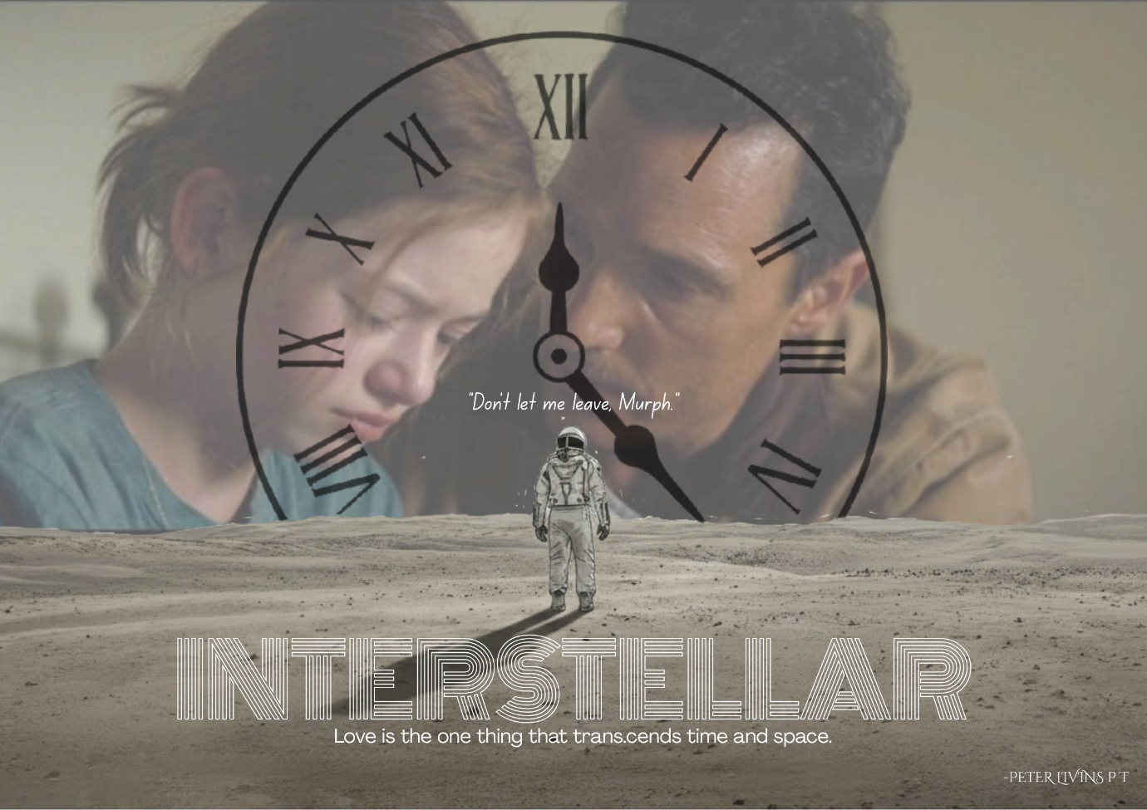

Movie Name: INTERSTELLAR by Christopher Nolan
Concept of the Poster: This poster visualizes the intersection of human emotion and cosmic physics by placing the bond between Cooper and Murph at the center of a clock face, symbolizing how time is the primary antagonist of their relationship. The solitary astronaut standing on a barren landscape emphasizes the vast isolation of space, while the transparent clock illustrates that every second spent exploring the stars costs years of life on Earth. By overlaying the heartbreaking plea, “Don’t let me leave, Murph”, the design highlights the movie’s core message: that love is the only force capable of transcending the rigid dimensions of time and space.

